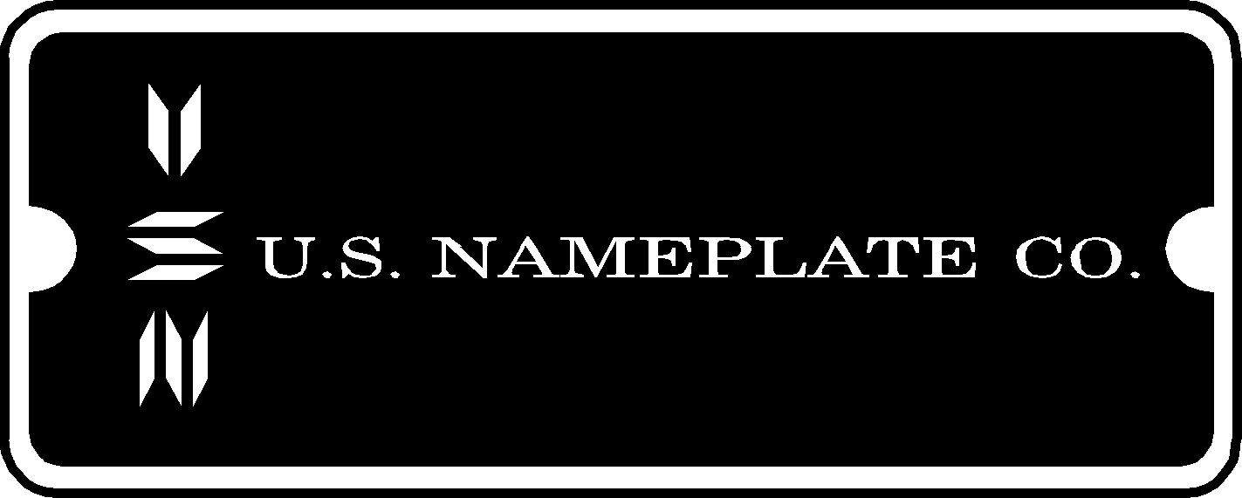

Highway 30 West
Mt. Vernon, IA 52314

PRODUCT IDENTIFICATION
NAMEPLATES, LABELS, DECALS, CONTROL PANELS ON A WIDE VARIETY OF SUBSTRATES
Phone: 319-895-8804 Toll Free: 1-800-553-8871 Fax: 319-895-8635
www.usnameplate.com

We appreciate very much receiving your order and we are anxious to establish a good business relationship which we hope will last many years. One of the key elements of a good business relationship is the establishment of credit which will allow us to ship to you and invoice you later. A good credit relationship also allows you to take advantage of our 1 ½ % 10 day; net 30 terms.

Many Thanks,
Cory Townsend
Accounting

Please fill in the blanks below:
Name: Fax:
Federal ID: Phone:

Trade References:

(1) Name:
Address:
City:
State: Zip:
Phone:
Fax:

(2) Name:
Address:
City:
State: Zip:
Phone:
Fax:
(3) Name:
Address:
City:
State: Zip:
Phone:
Fax:

(4) Name:
Address:
City:
State: Zip:
Phone:
Fax:

